Color Permutation NCA_ ARC1 Train =53 solved tasks

025d127b
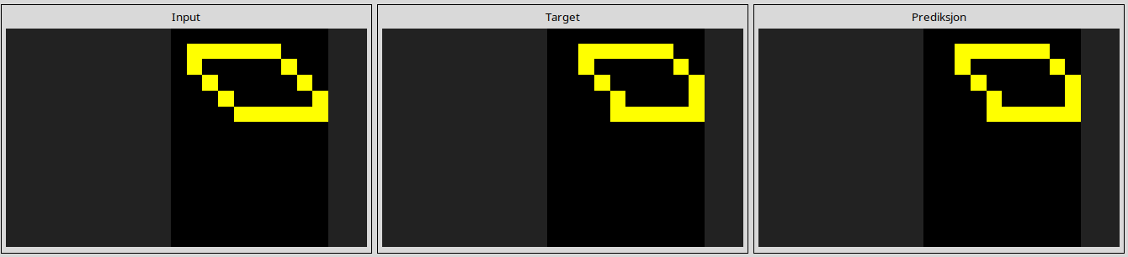
0962bcdd
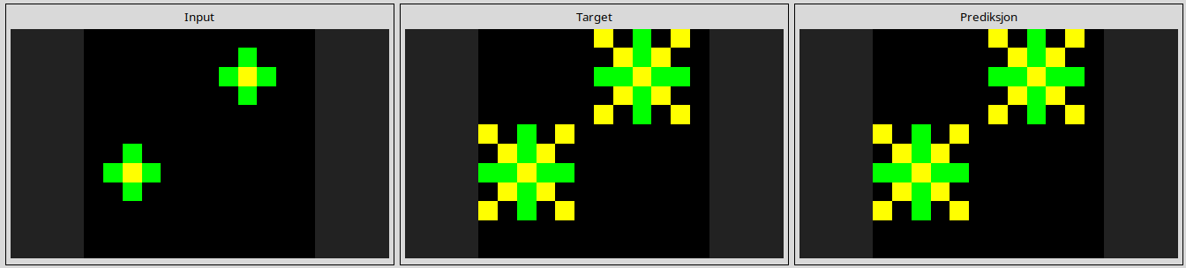
1190e5a7
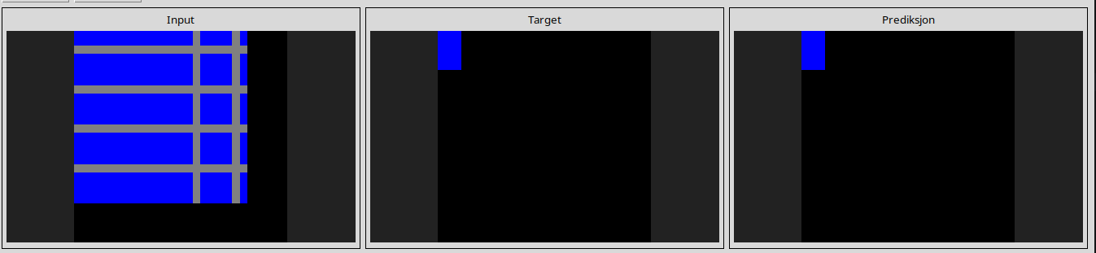
25d8a9c8
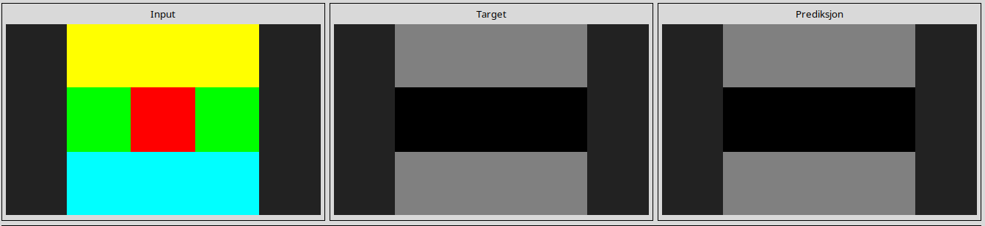
25ff71a9
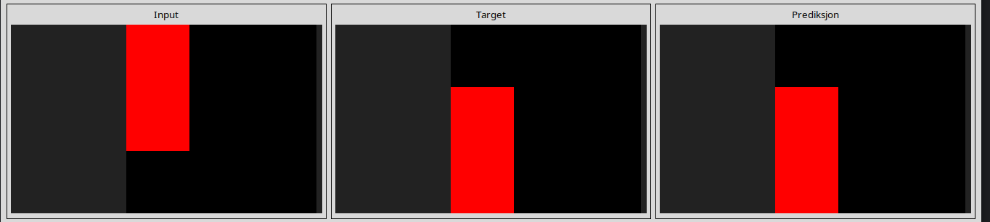
2dee498d
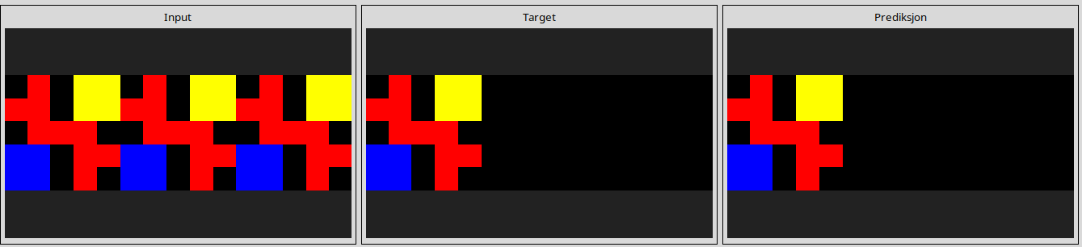
3618c87e
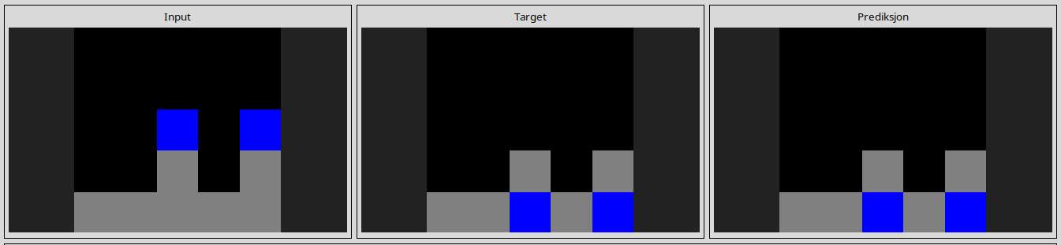
3aa6fb7a
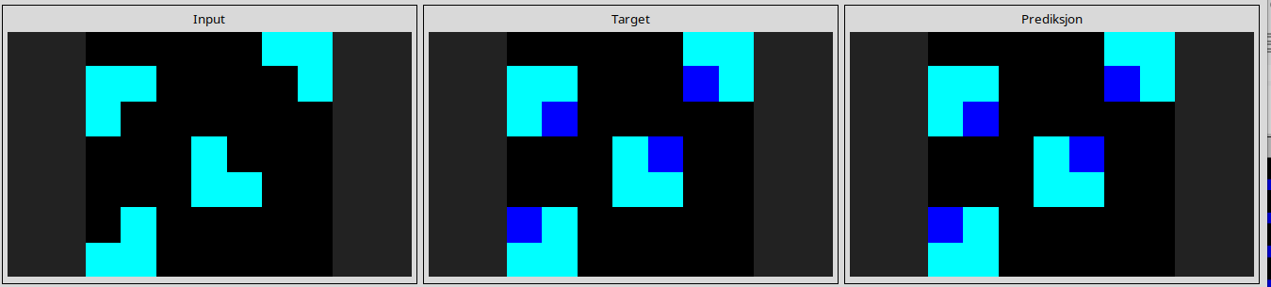
3befdf3e
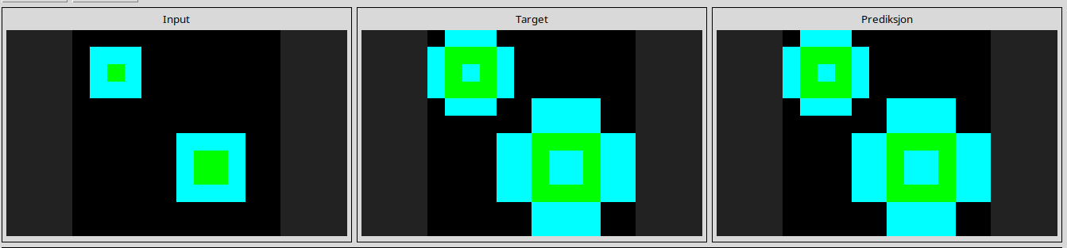
3c9b0459
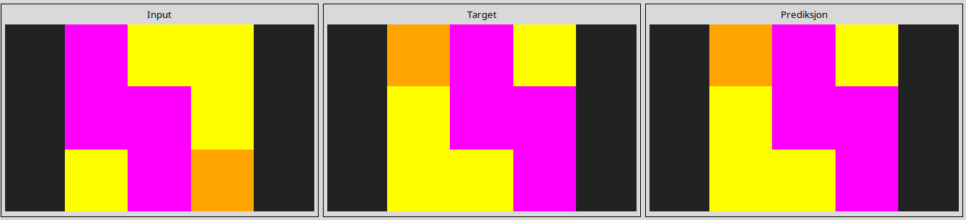
4258a5f9
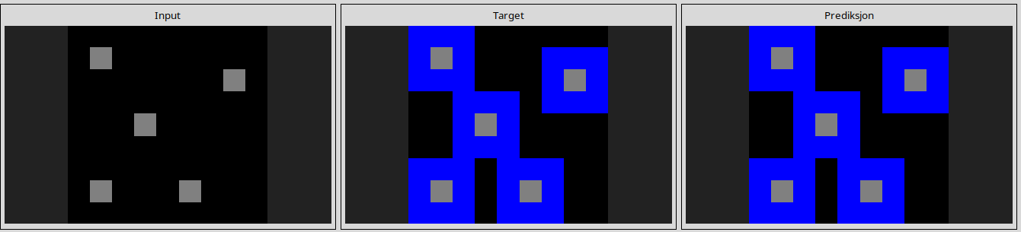
42a50994
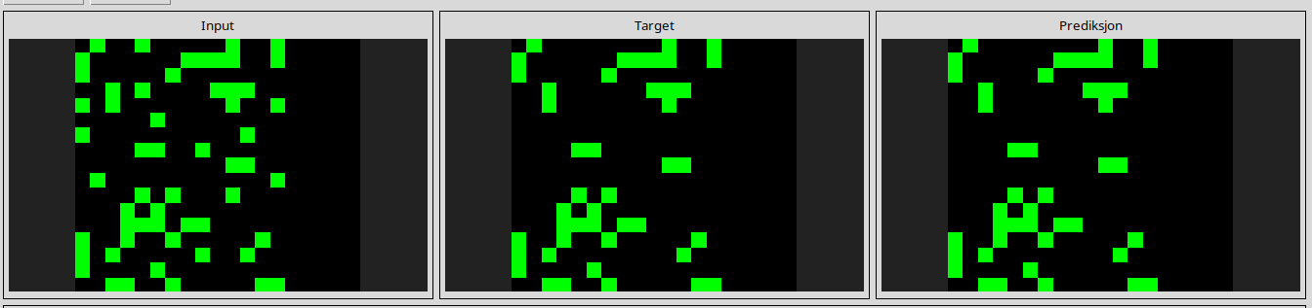
4347f46a
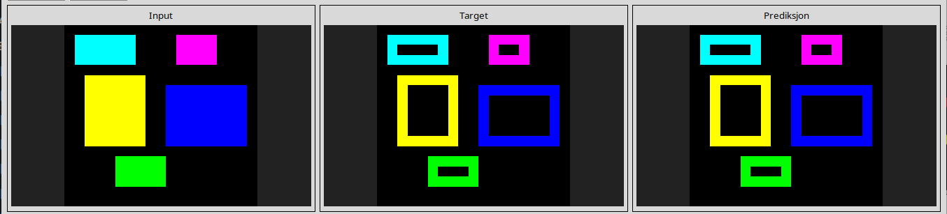
444801d8
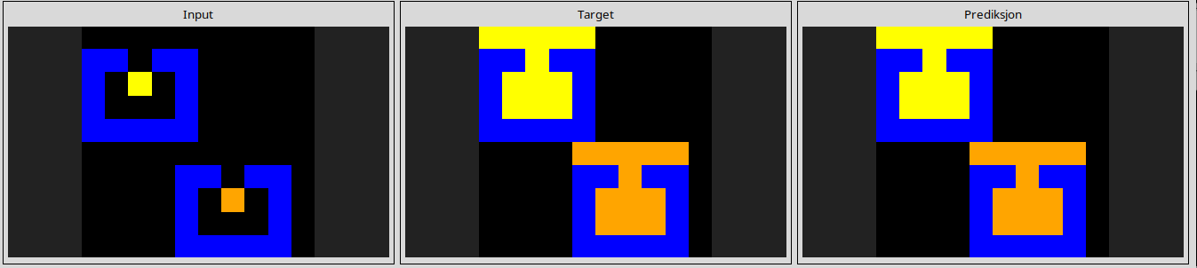
44f52bb0
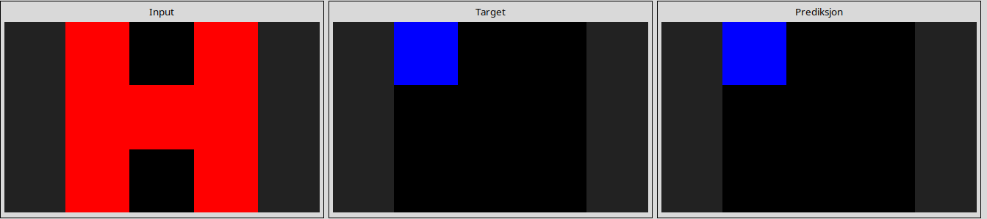
49d1d64f
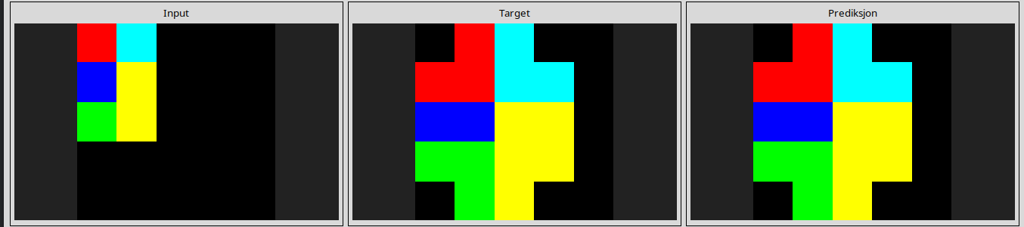
5168d44c
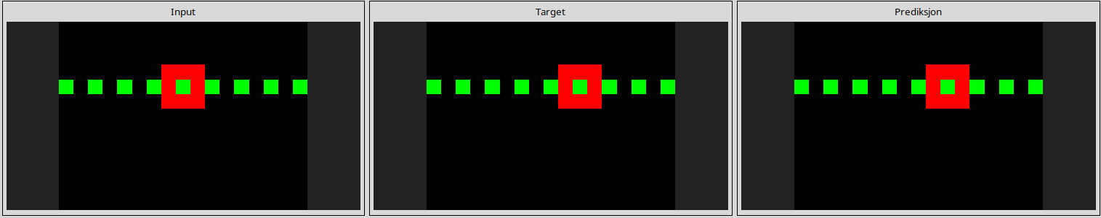
543a7ed5
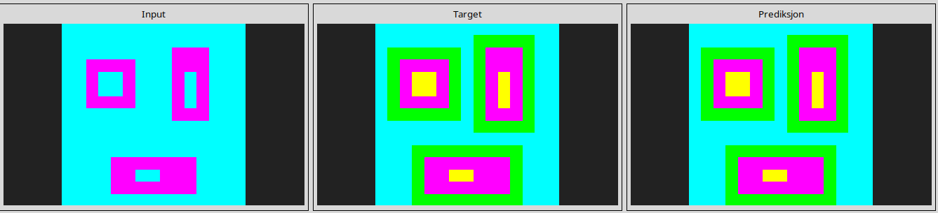
623ea044
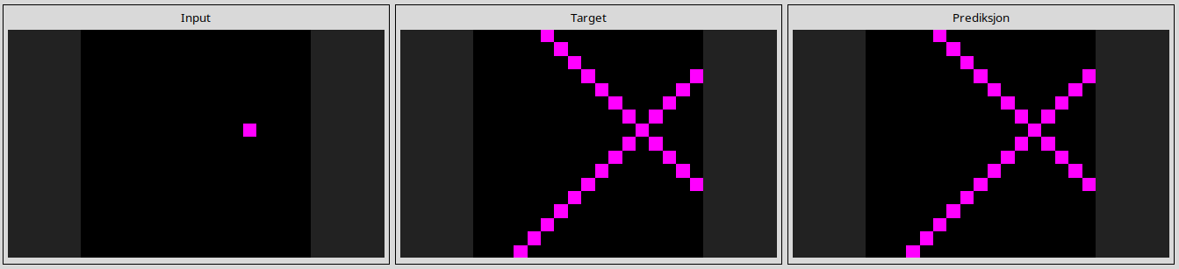
67385a82
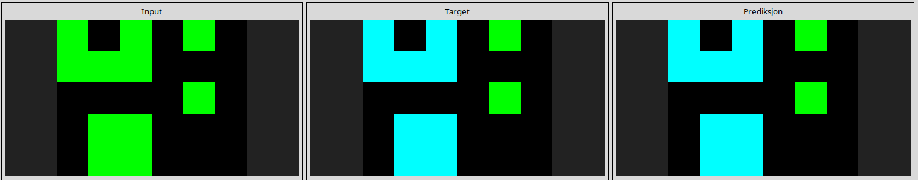
694f12f3
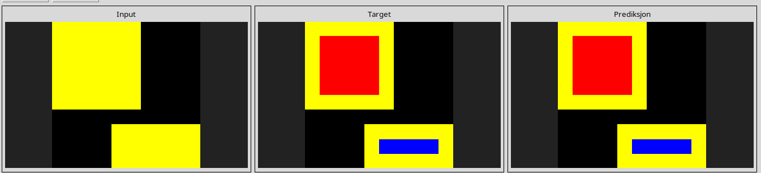
6c434453
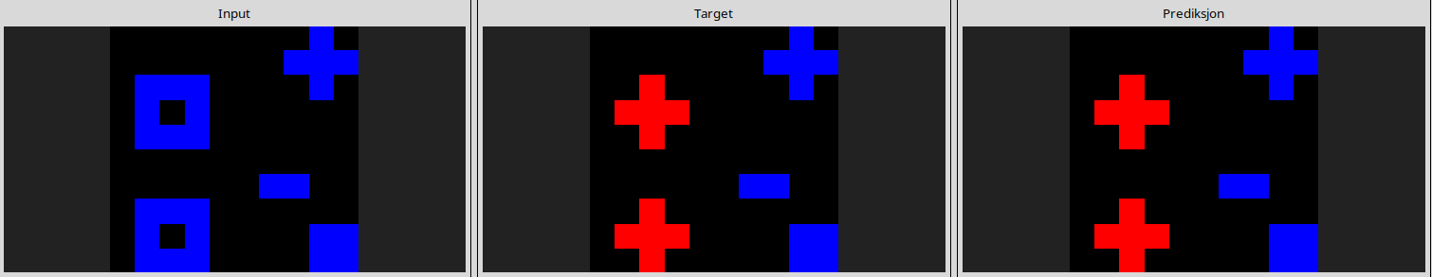
6f8cd79b
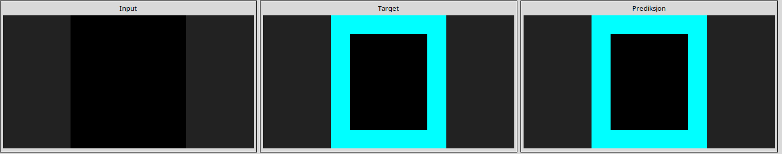
74dd1130
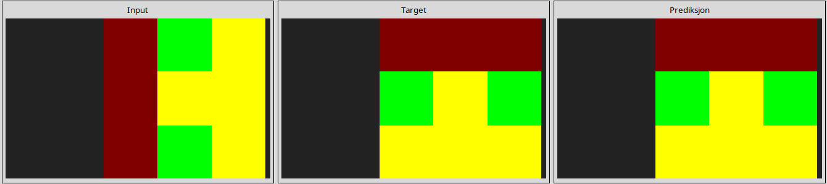
7b7f7511
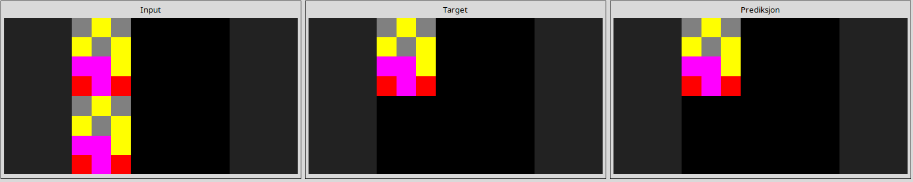
7ddcd7ec
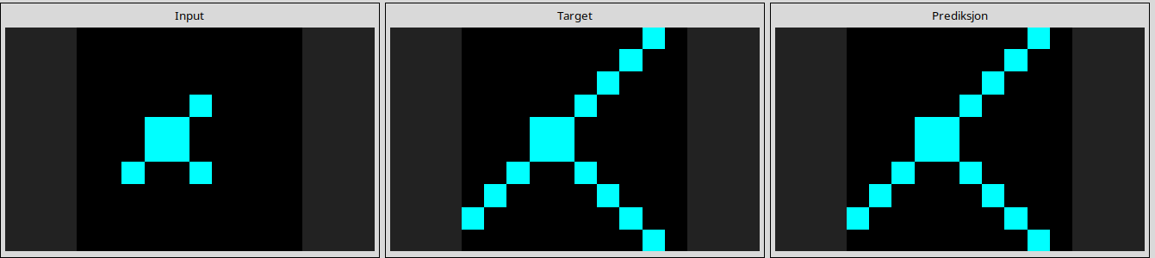
7e0986d6
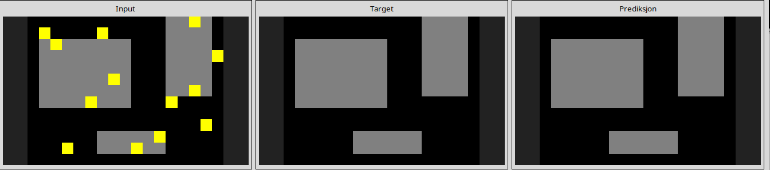
7f4411dc
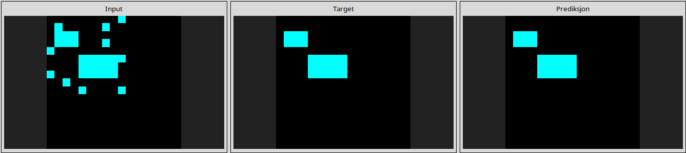
95990924
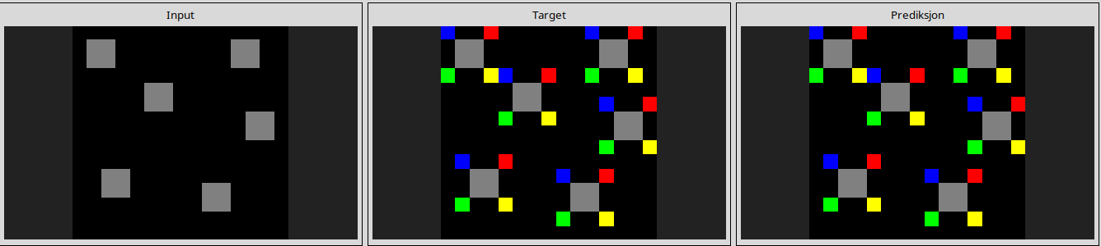
99fa7670
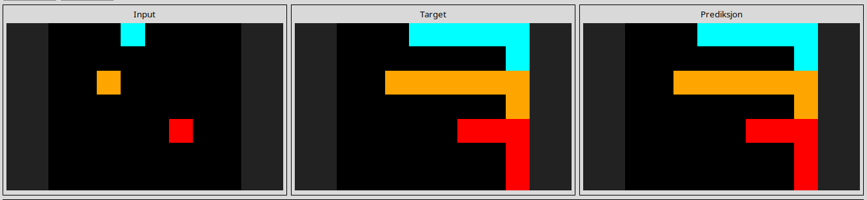
a65b410d
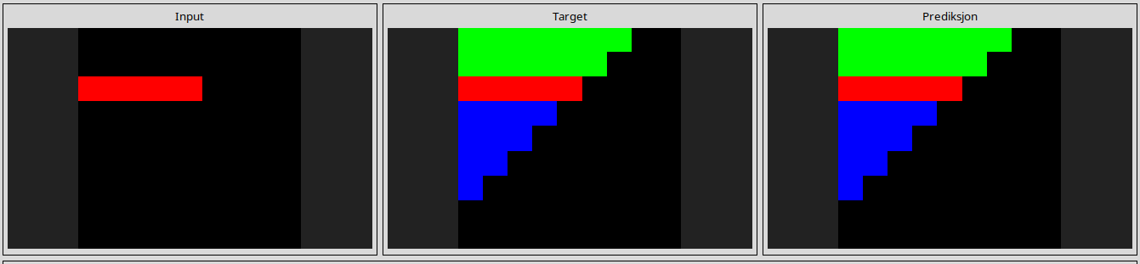
a699fb00
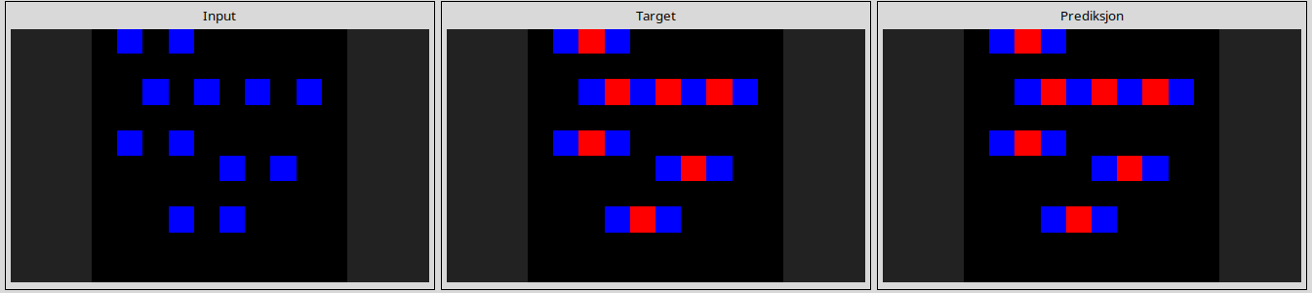
a79310a0
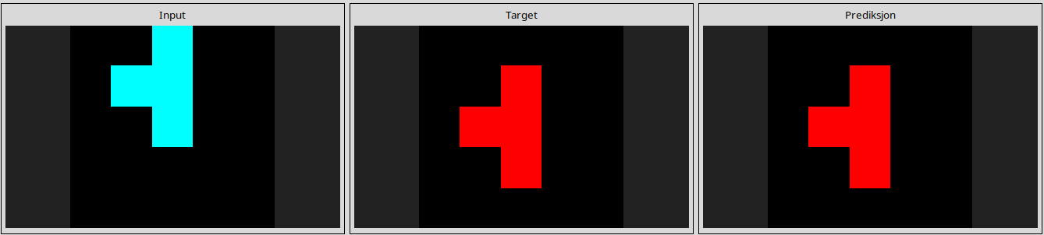
a85d4709
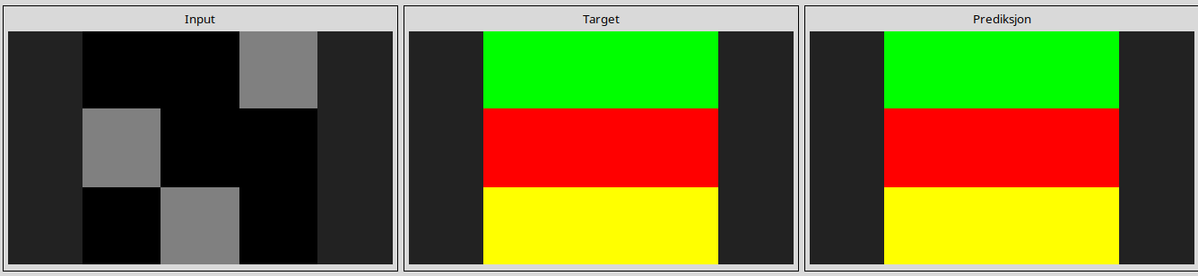
a9f96cdd
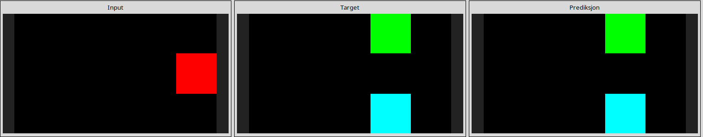
aedd82e4
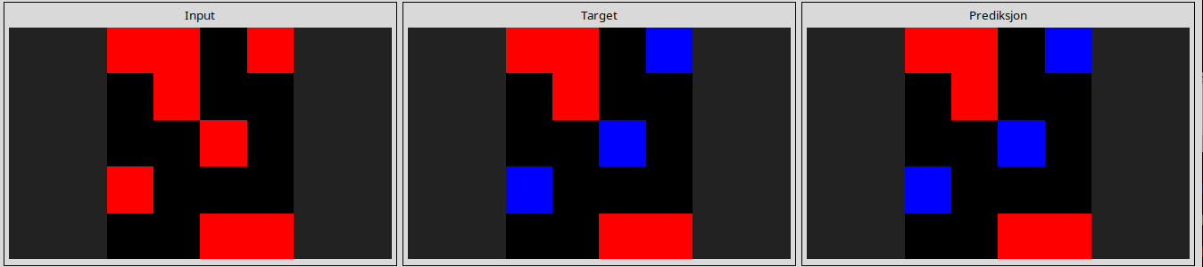
b60334d2
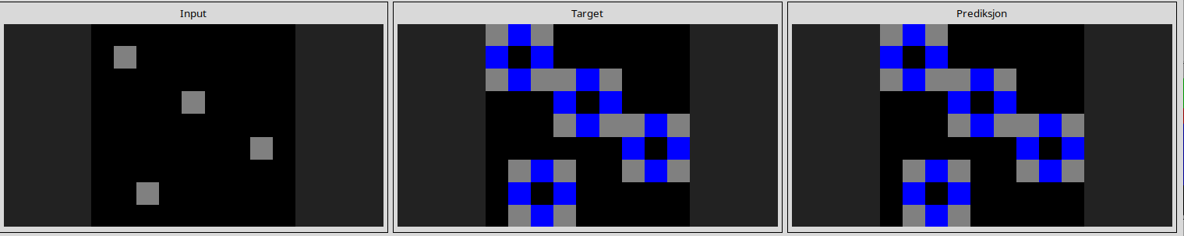
b6afb2da
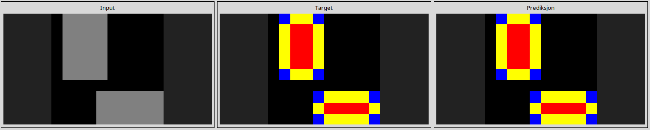
ba26e723
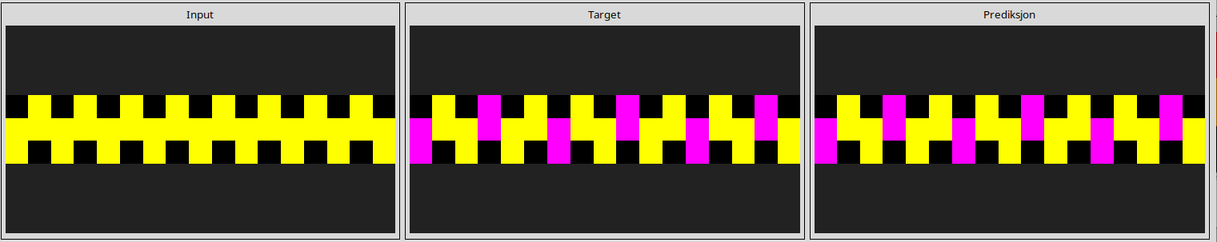
ba97ae07
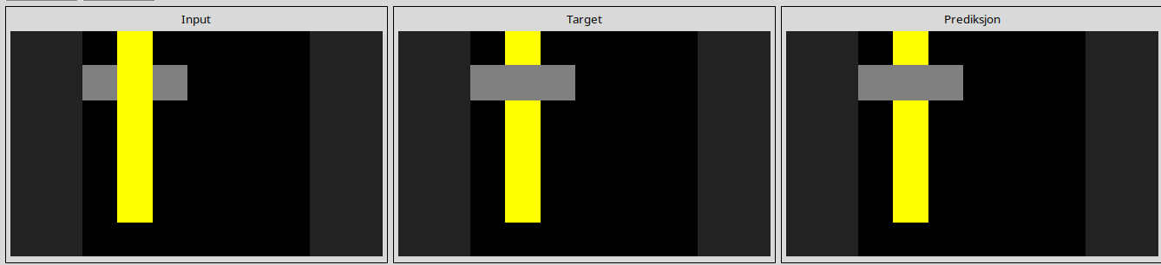
bb43febb
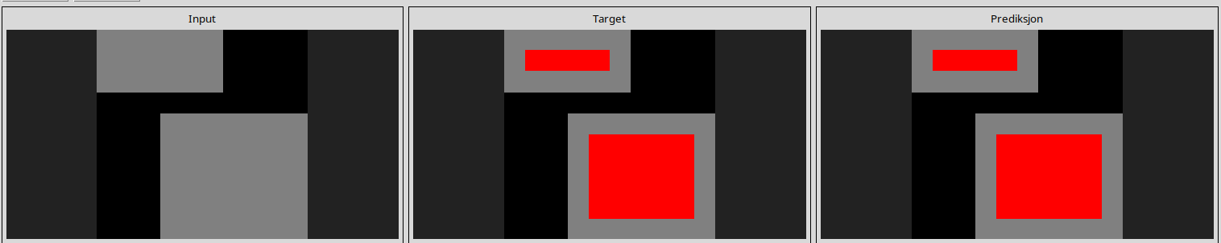
bbc9ae5d
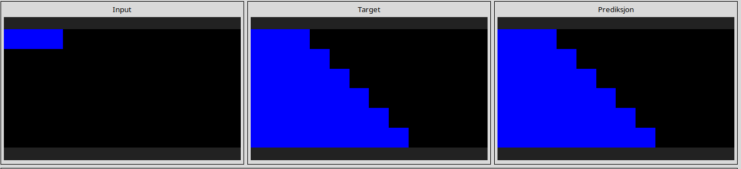
c0f76784
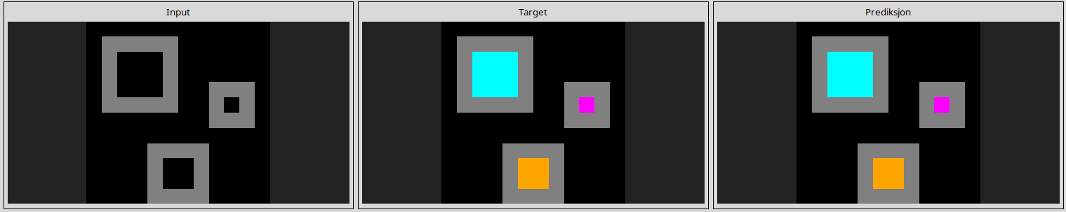
ce22a75a
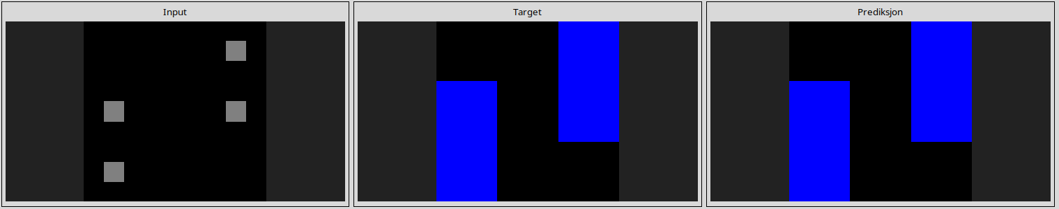
d037b0a7
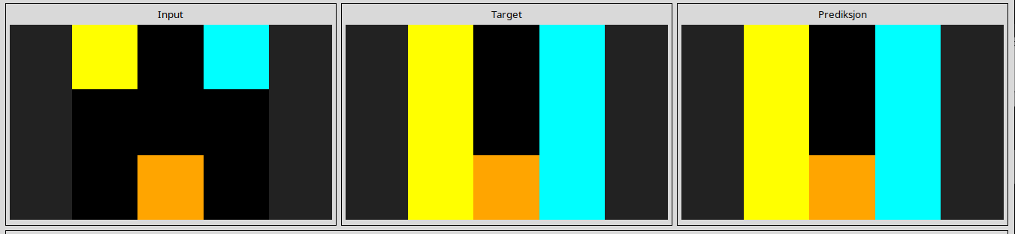
d06dbe63
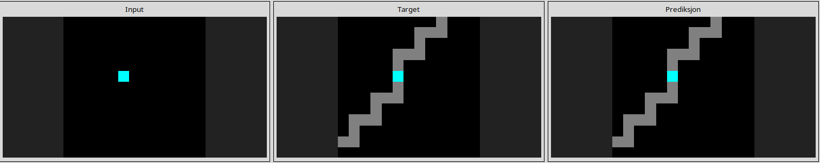
d10ecb37
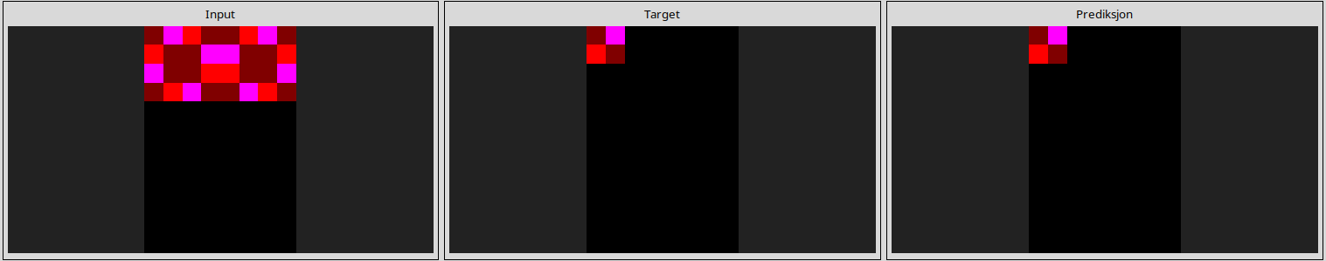
d13f3404
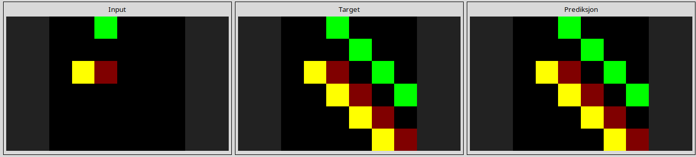
d4469b4b
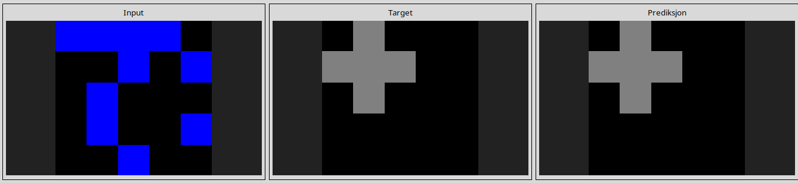
d631b094
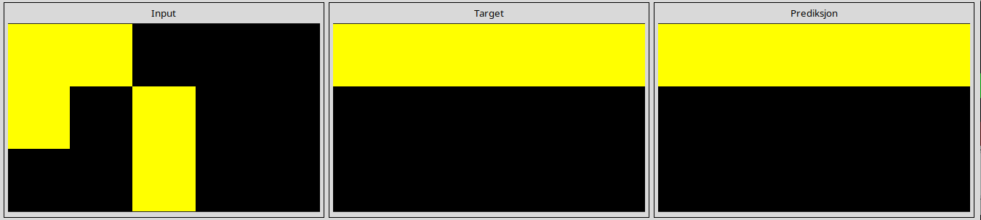
e8593010
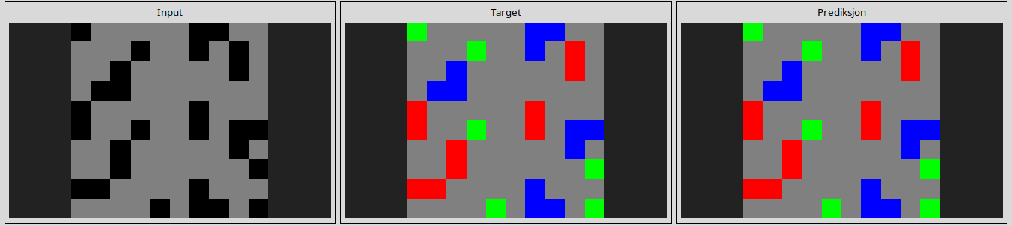
e9afcf9a
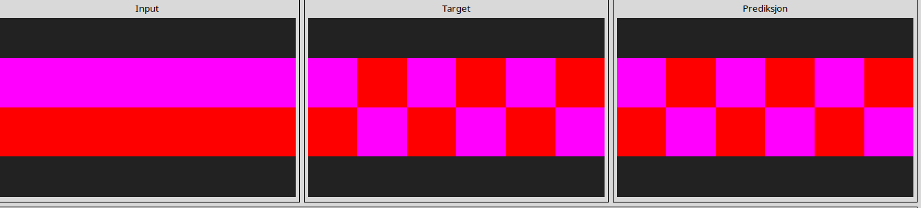
ef135b50
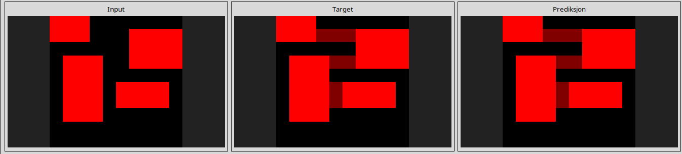
---------------------------------------------------------------------------------------------------------------
Almost solved tasks
1bfc4729
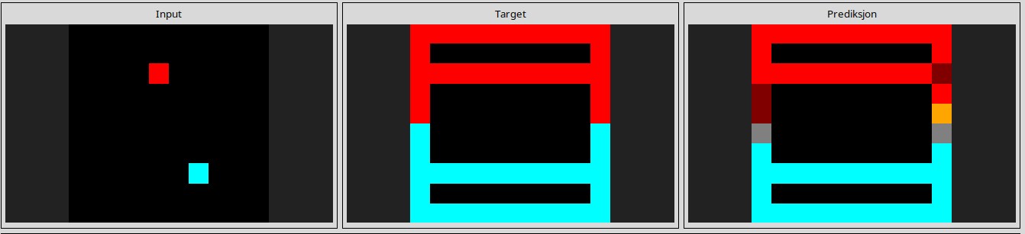
l
1e0a9b12
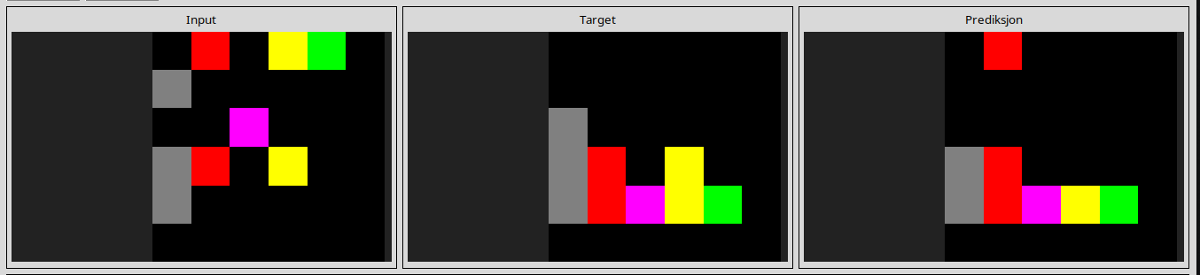
l
3ac3eb23
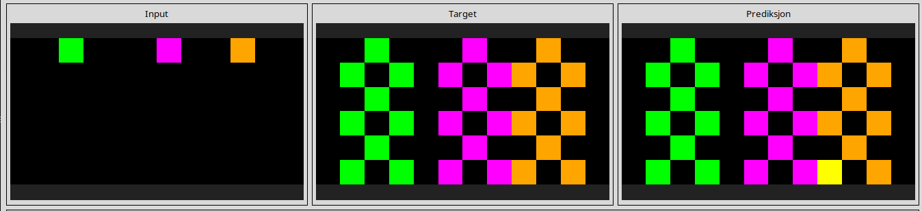
l
4c4377d9
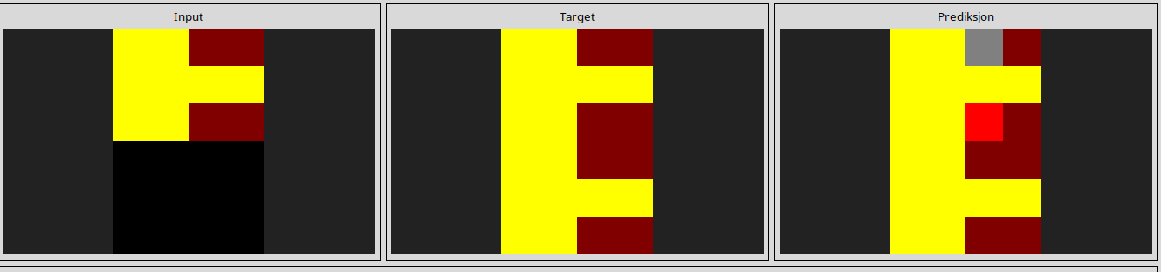
6d0aefbc
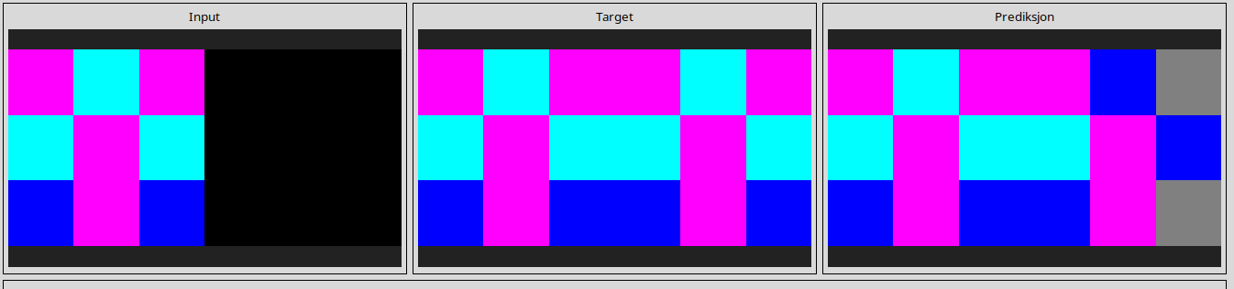
6d58a25d
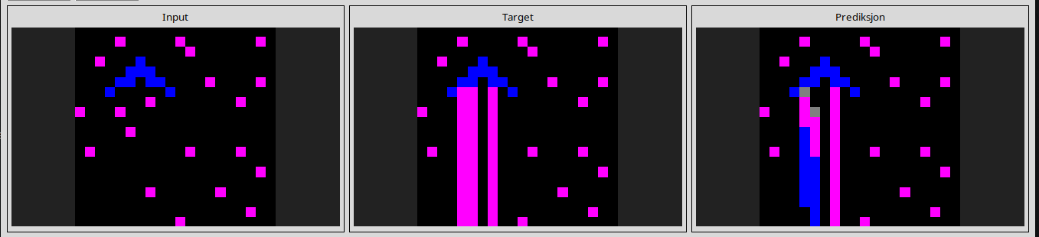
l
6e19193c
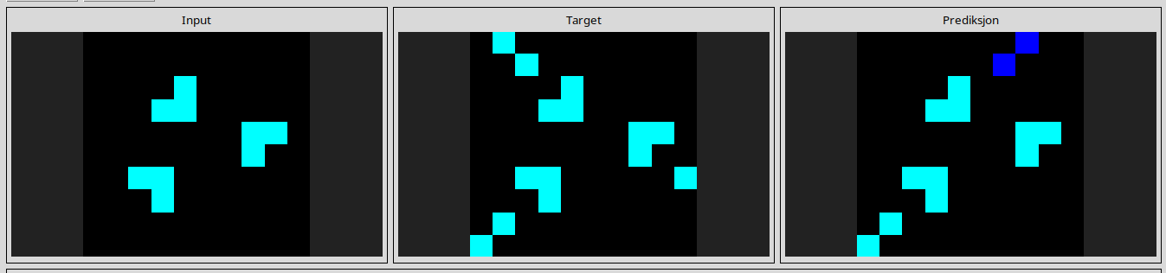
l
6fa7a44f
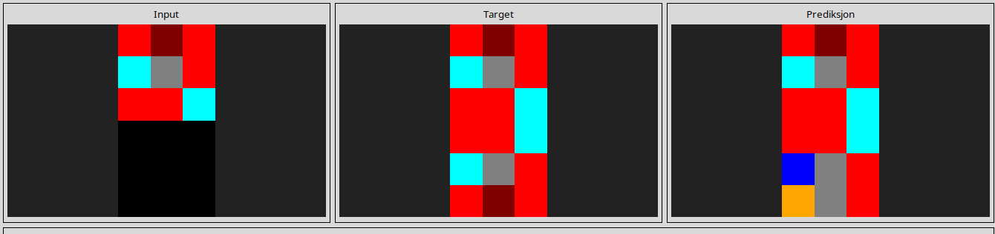
l
29c11459
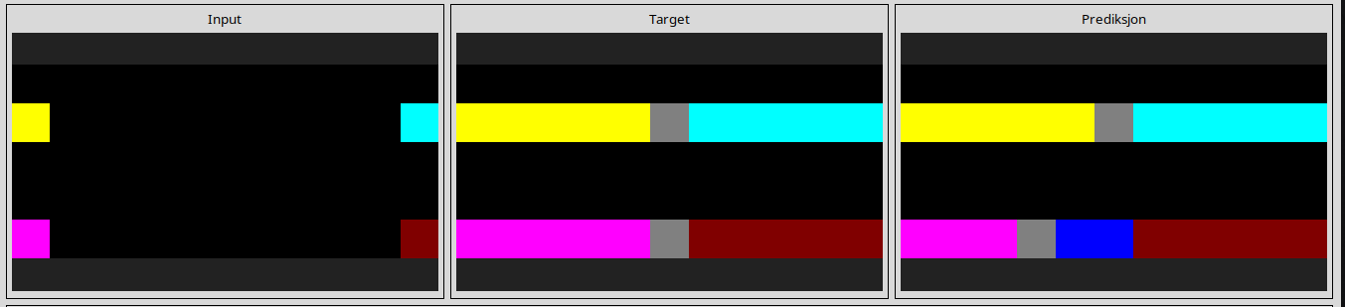
l
54d9e175
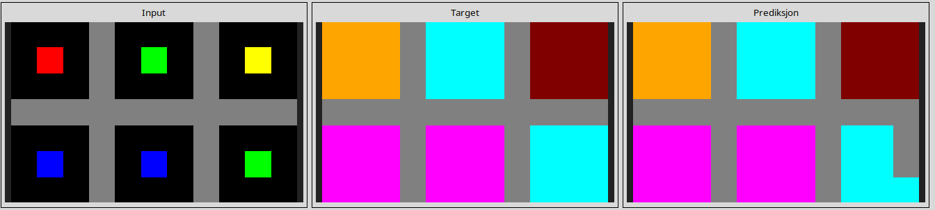
l
93b581b8
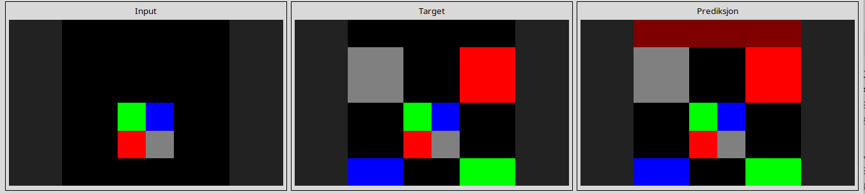
l
272f95fa
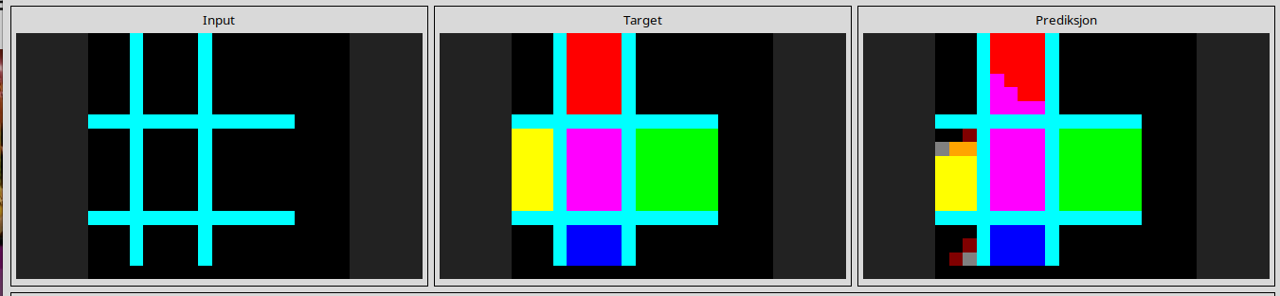
l
868de0fa
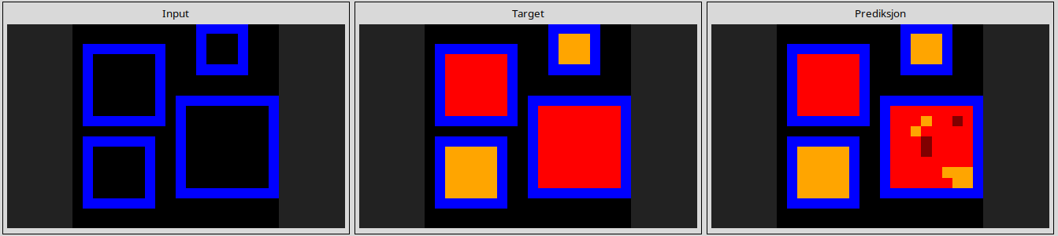
l
928ad970
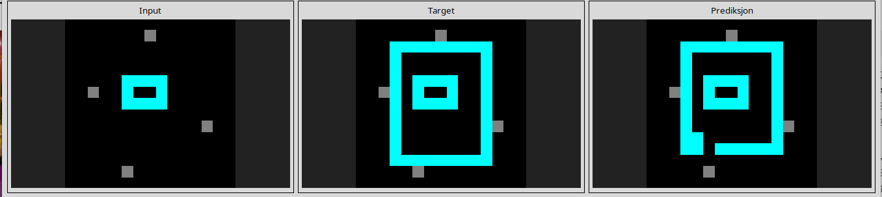
l
4612dd53
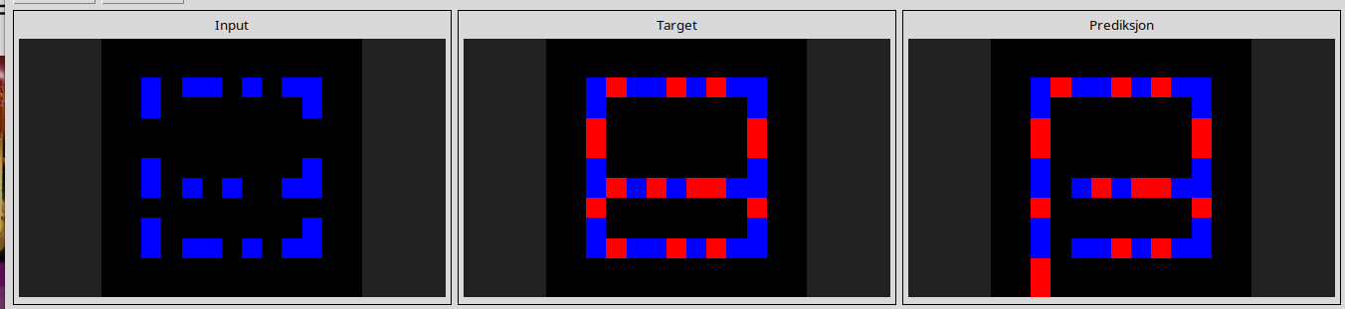
l
5521c0d9
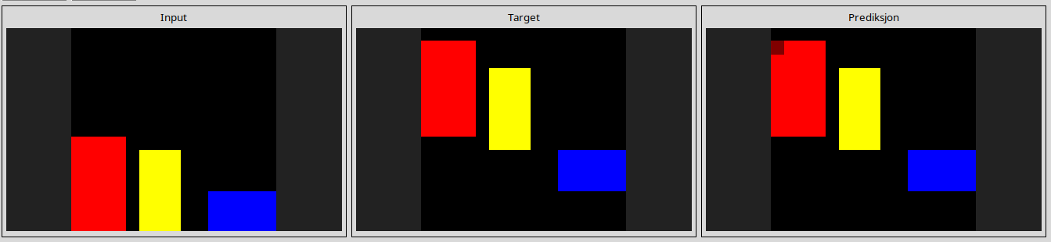
l
8403a5d5
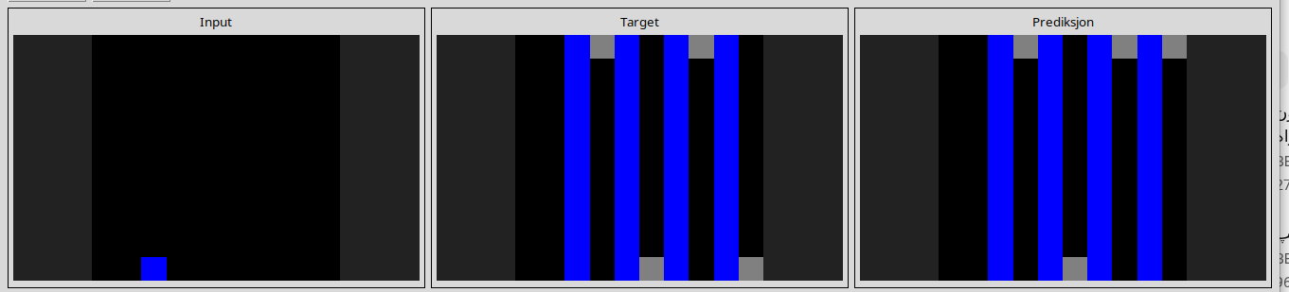
l
11852cab
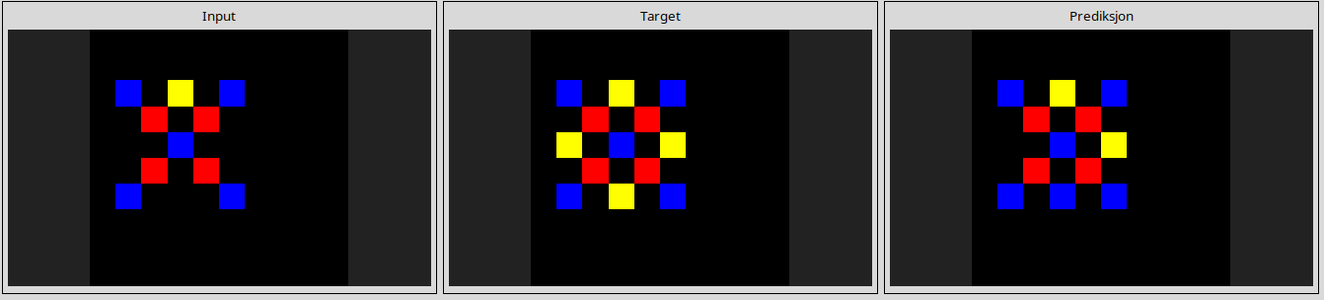
l
73251a56
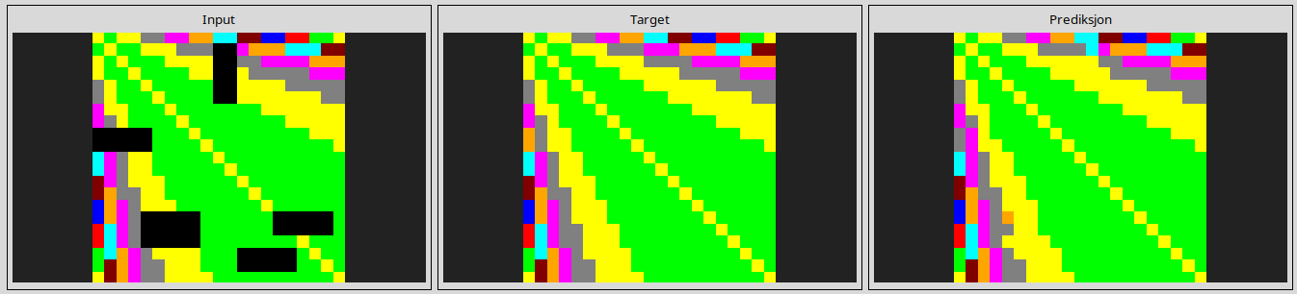
l
91714a58
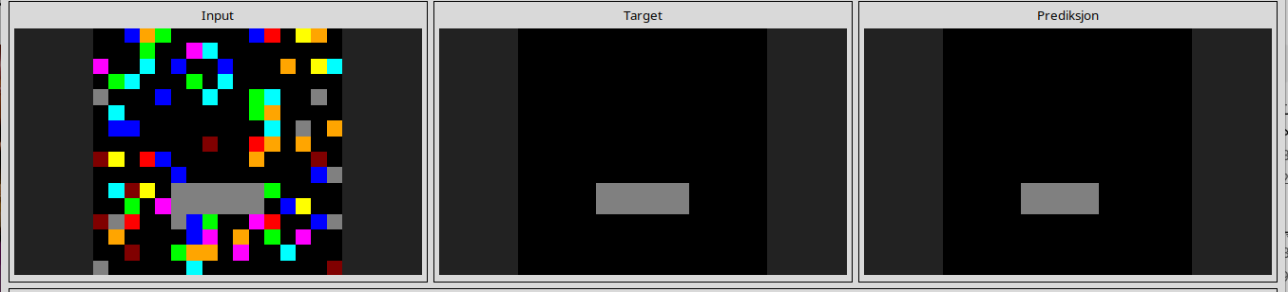
l
9565186b
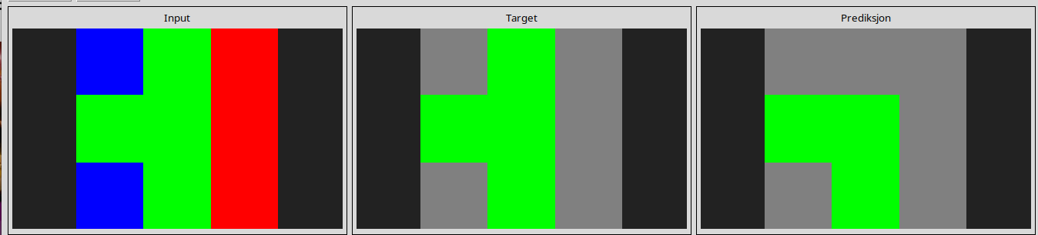
l
22168020
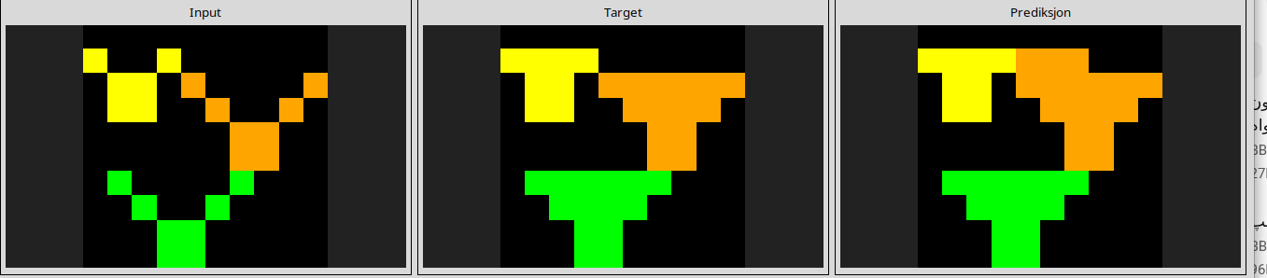
l
23581191
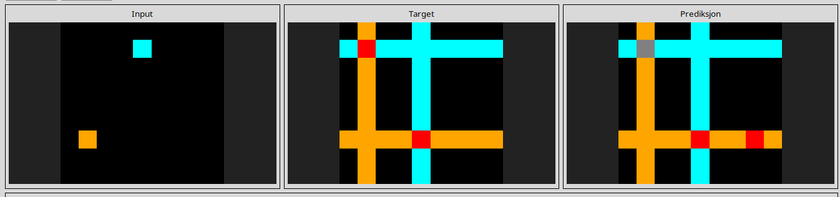
l
97999447
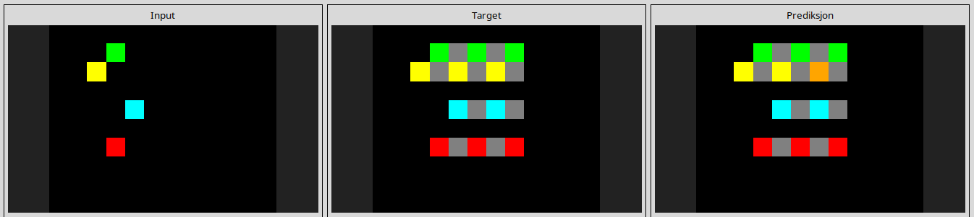
l
a2fd1cf0
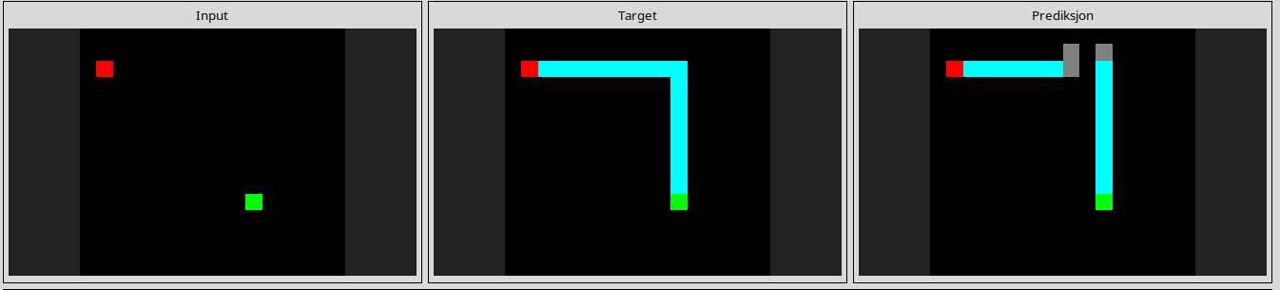
l
a64e4611
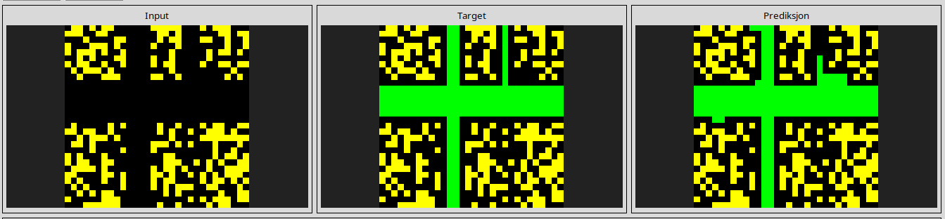
l
a78176bb
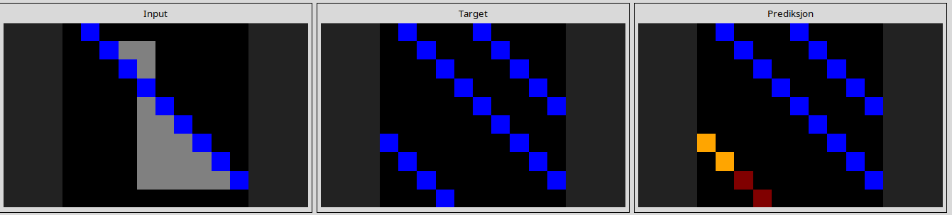
l
b8cdaf2b
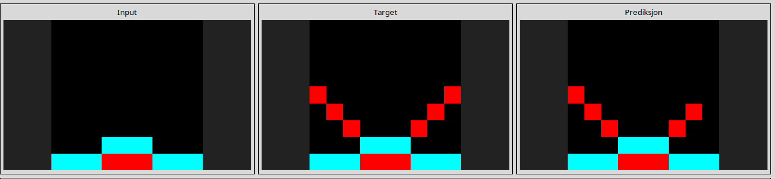
l
b27ca6d3
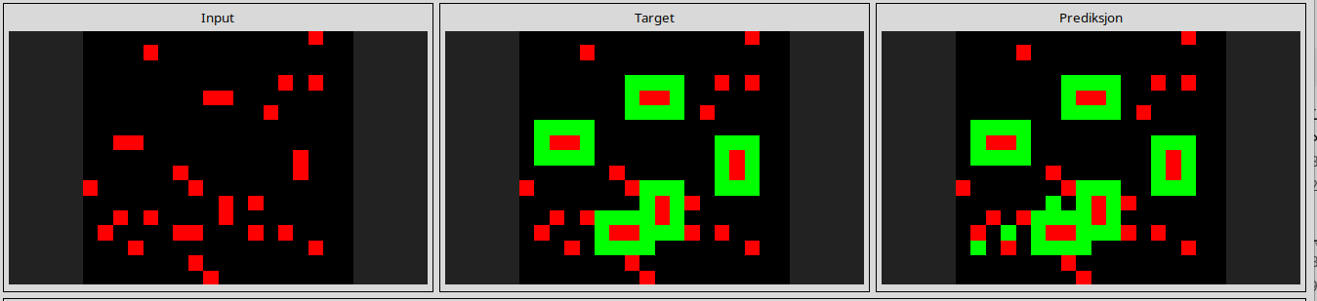
l
bda2d7a6
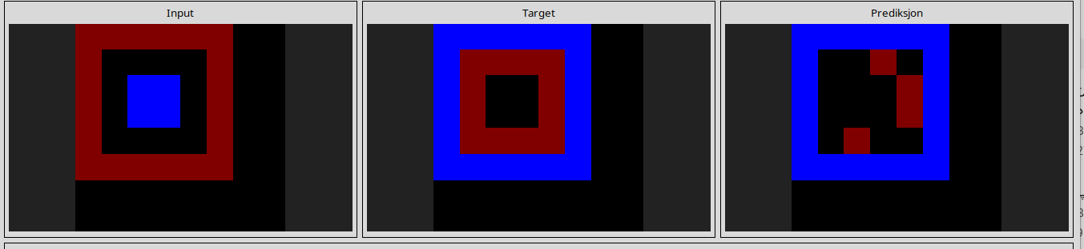
l
c3f564a4
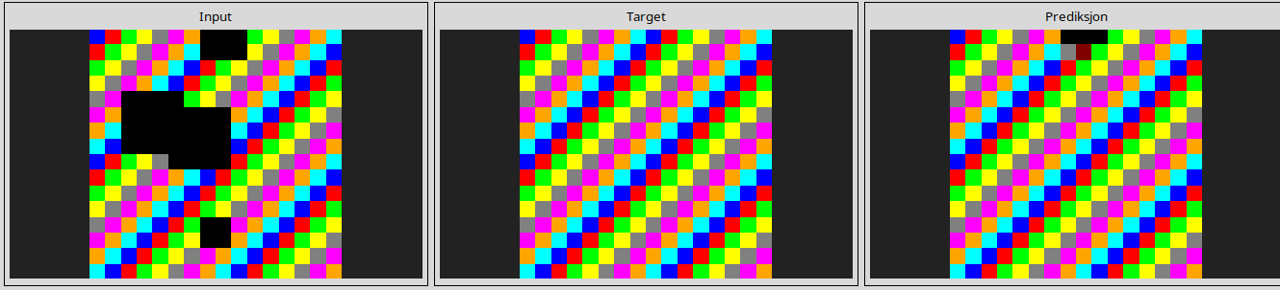
l
d0f5fe59
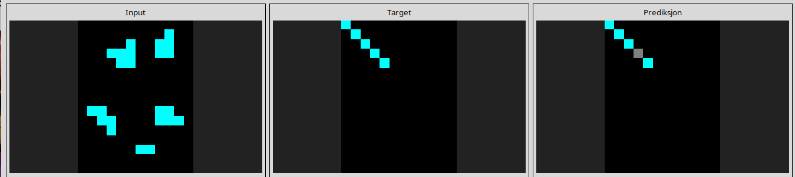
l
d9f24cd1
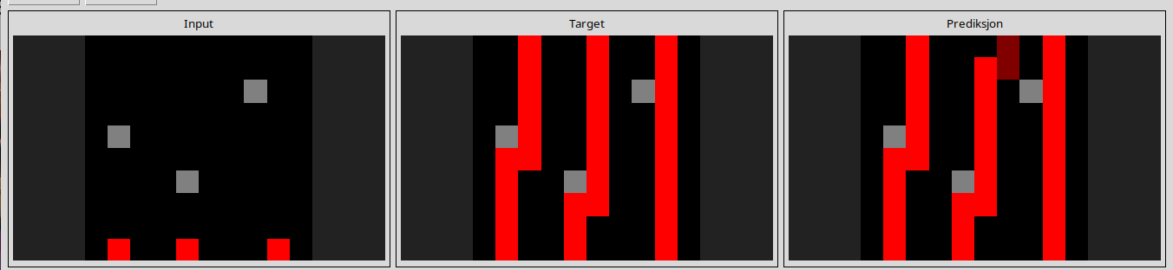
l
d406998b
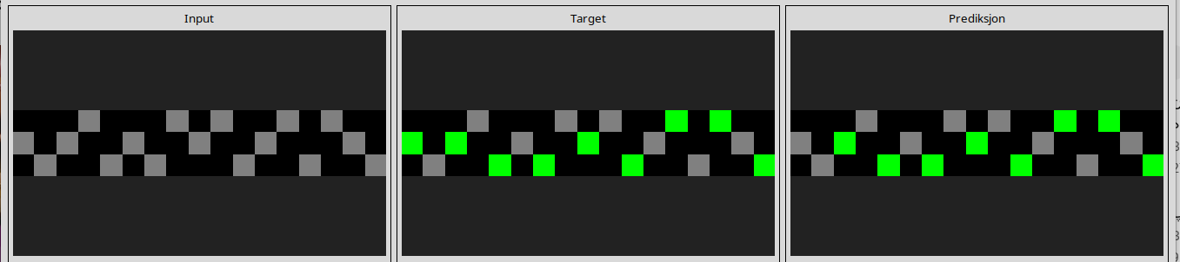
l
db3e9e38
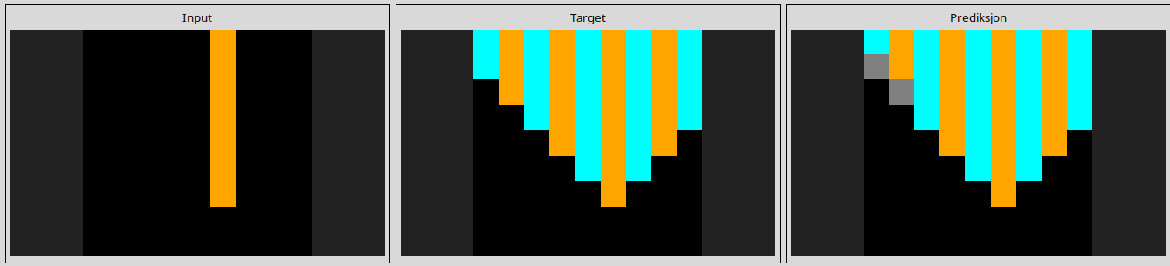
l
e73095fd
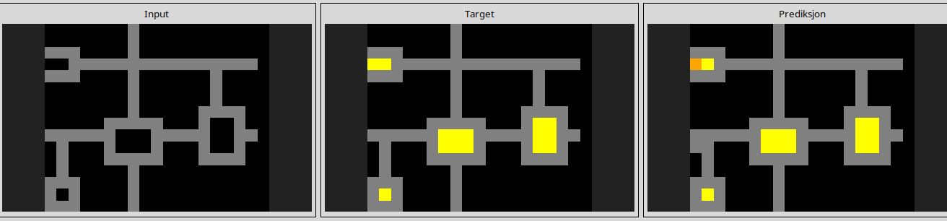
l
f8c80d96
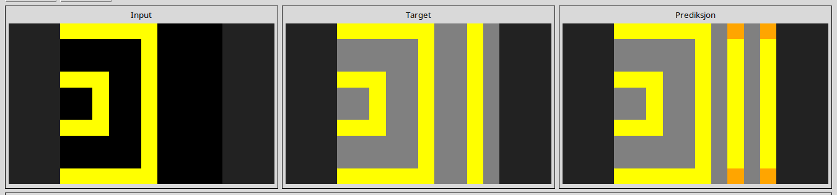
--------------------------------------------------------------------------------------------------------------

Reasoning pitfall
correct color but different object
1cf80156

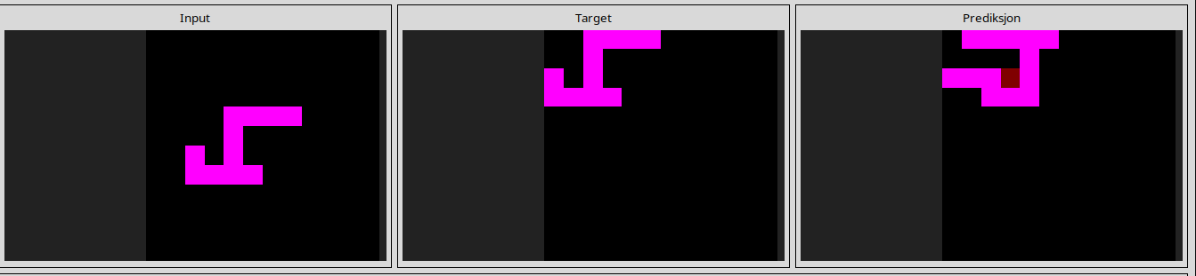
l
8d5021e8
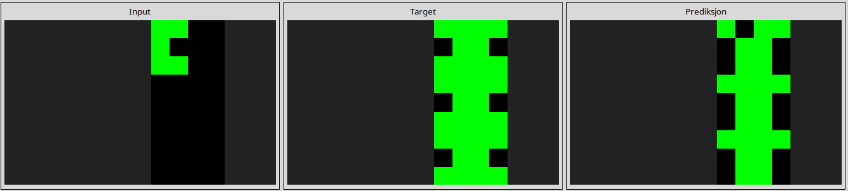
l
8eb1be9a
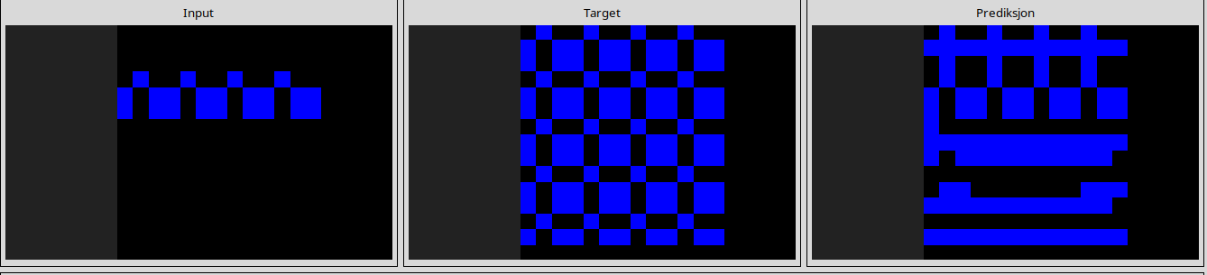
l
28bf18c6

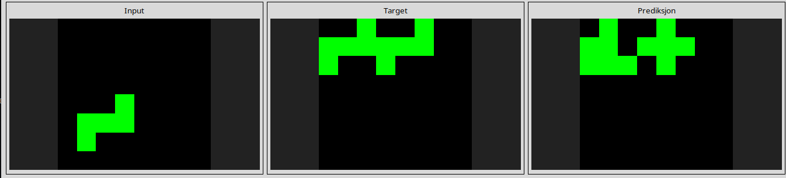
l
48d8fb45
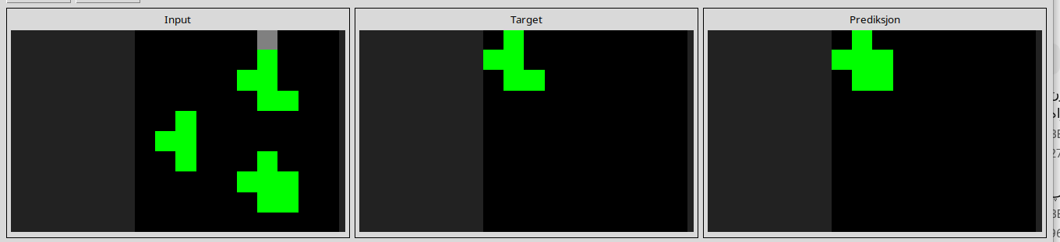
22eb0ac0

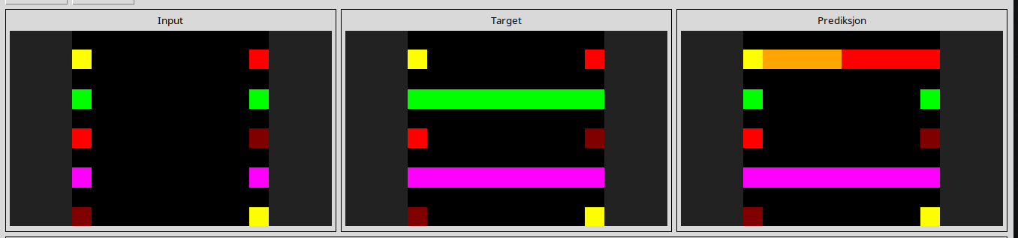
l
25d487eb
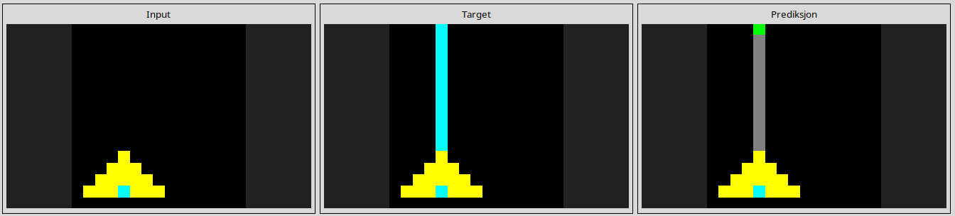
l
54d82841
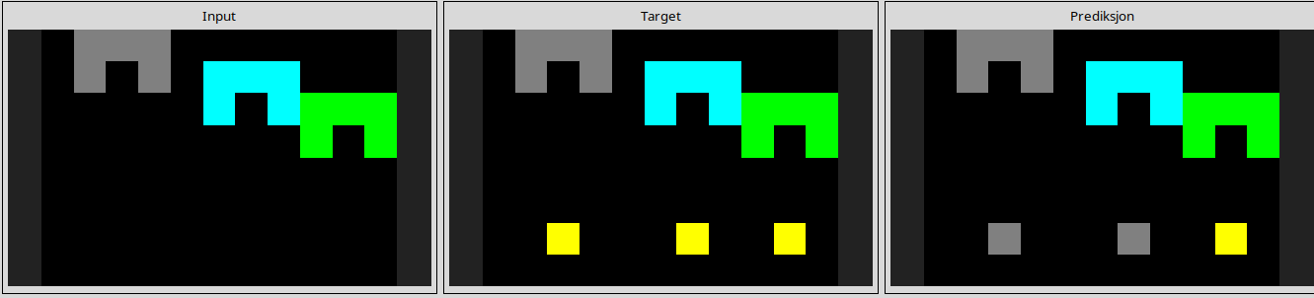
l
67a423a3
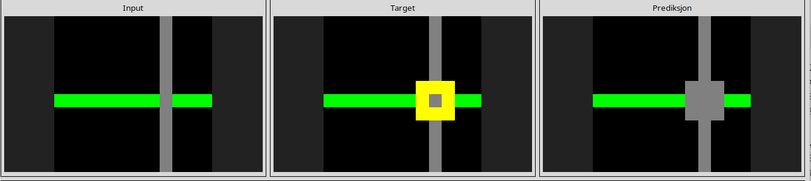
l
952a094c
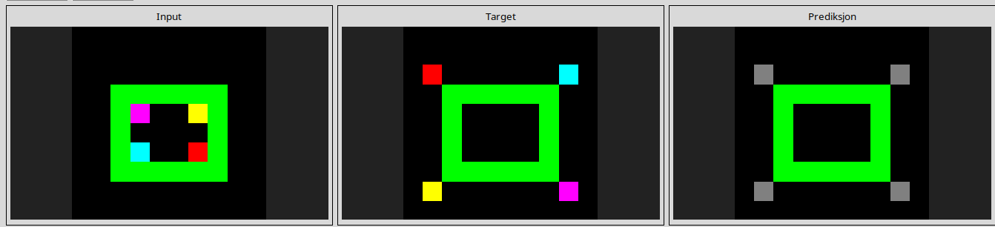
l
a5f85a15
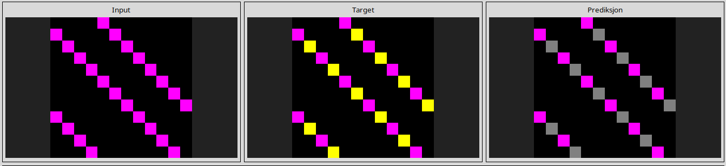
l
d6ad076f
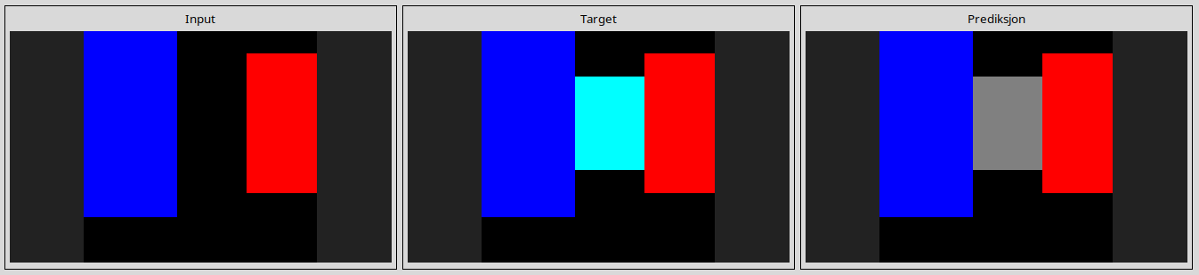
l
d07ae81c
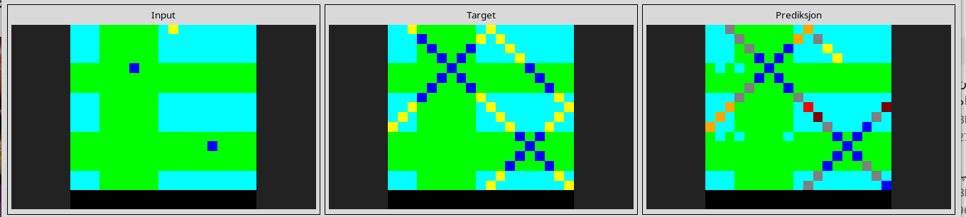
l
eb281b96
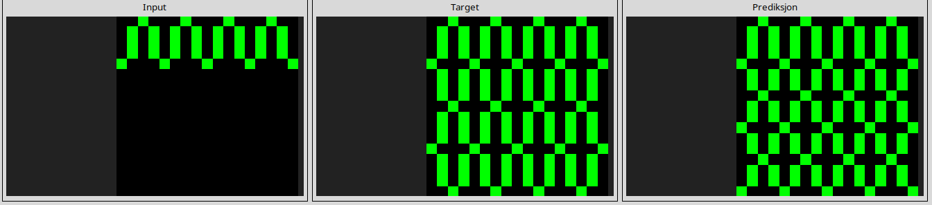
-----------------------------------------------------------------------------------------------------------------
Tasks that are ruined due to color permutation
0d3d703e
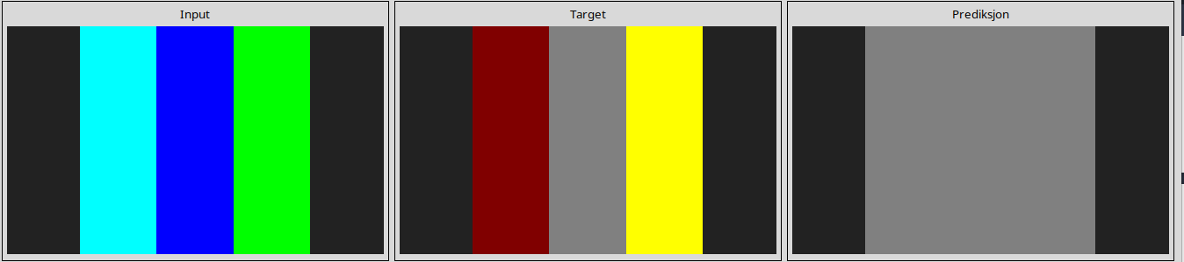
l
5c0a986e
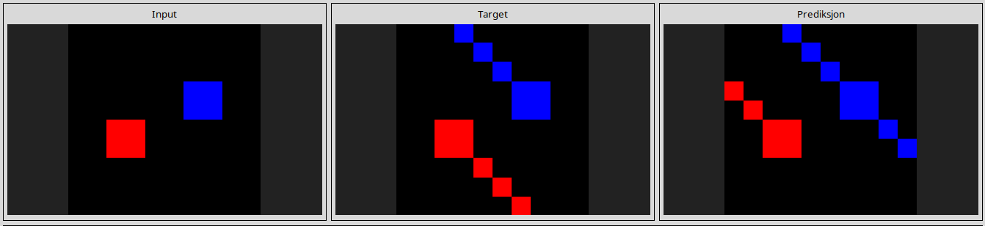
l
6cf79266
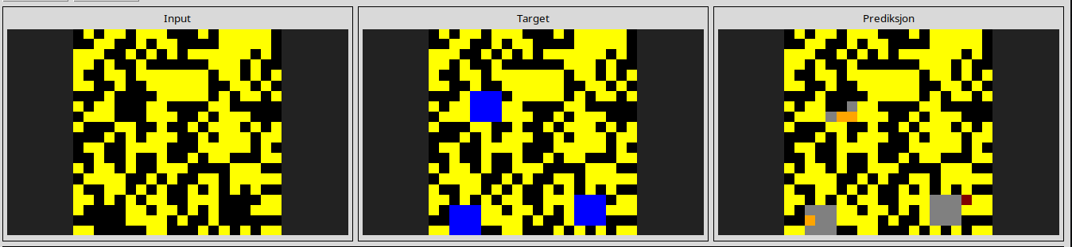
l
27a28665
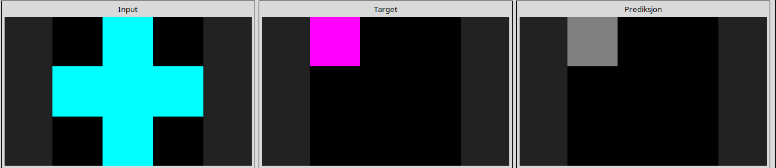
l
50cb2852
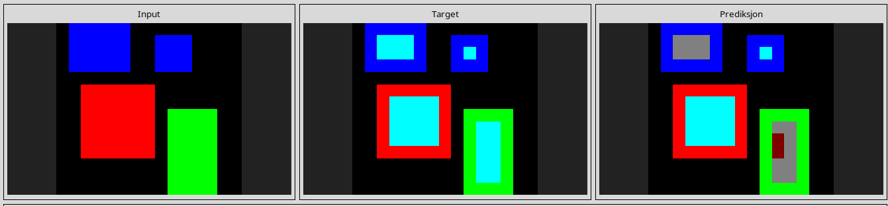
l
662c240a
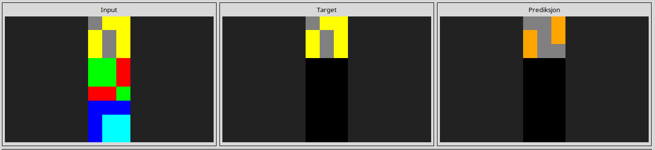
l
32597951
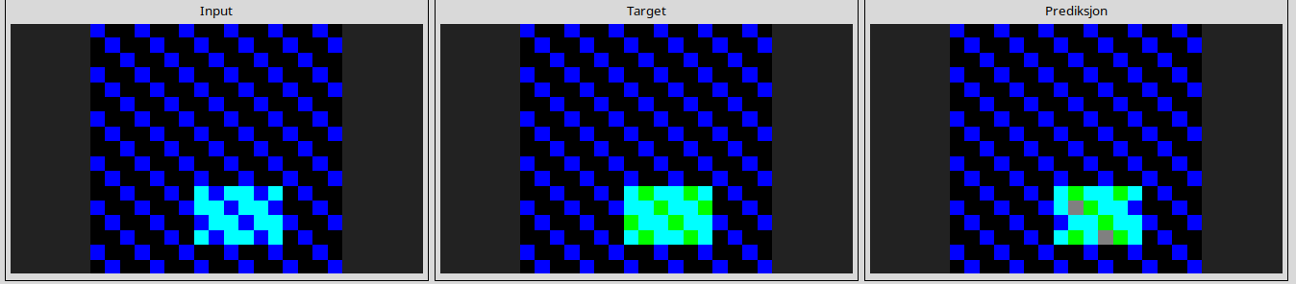
l
a5313dff
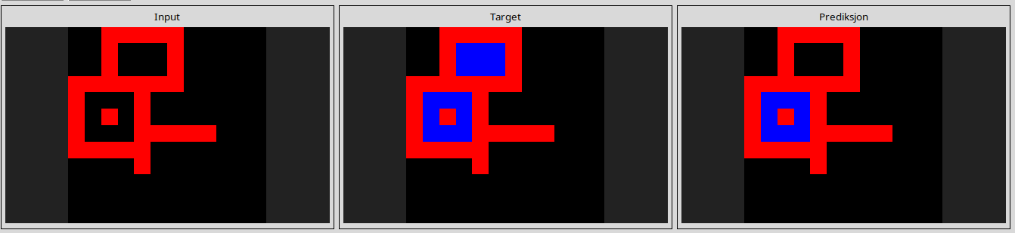
l
b1948b0a
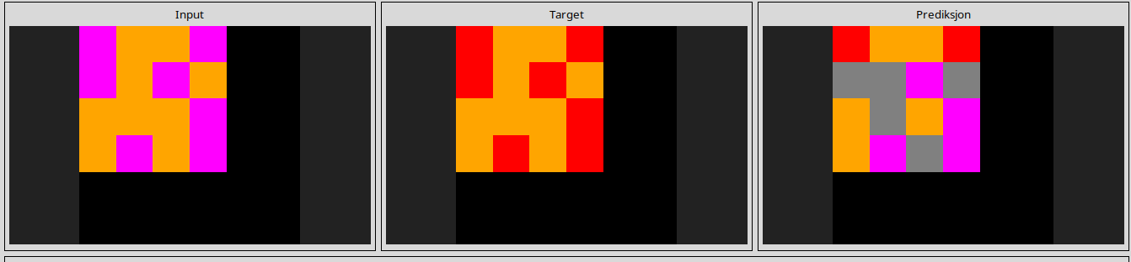
l
c8f0f002
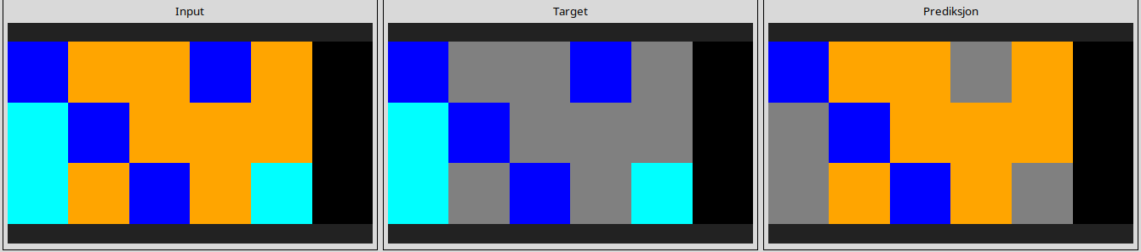
l
ce9e57f2
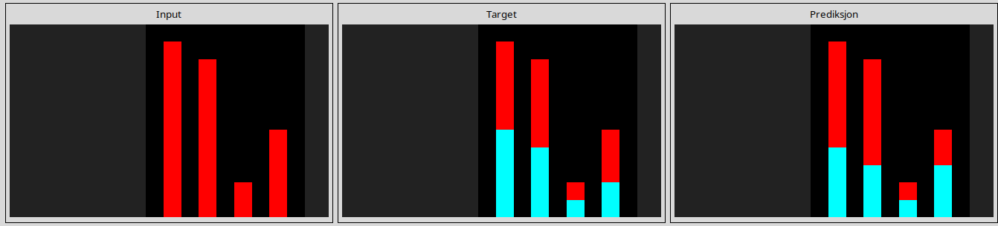
l
d364b489
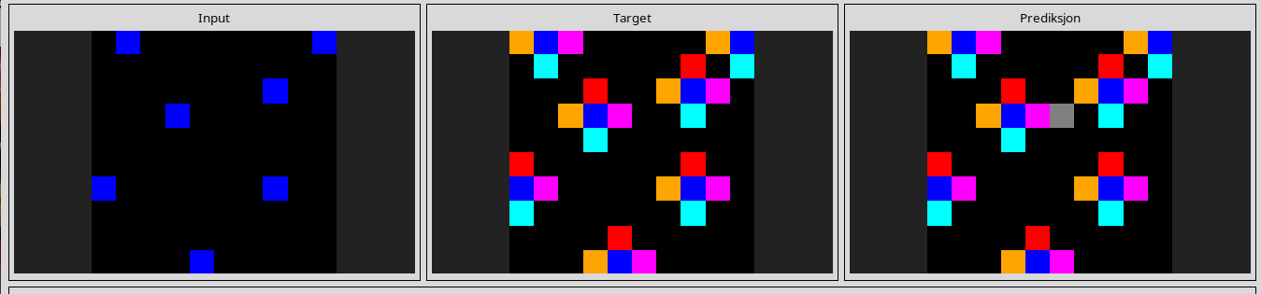
l
dc433765
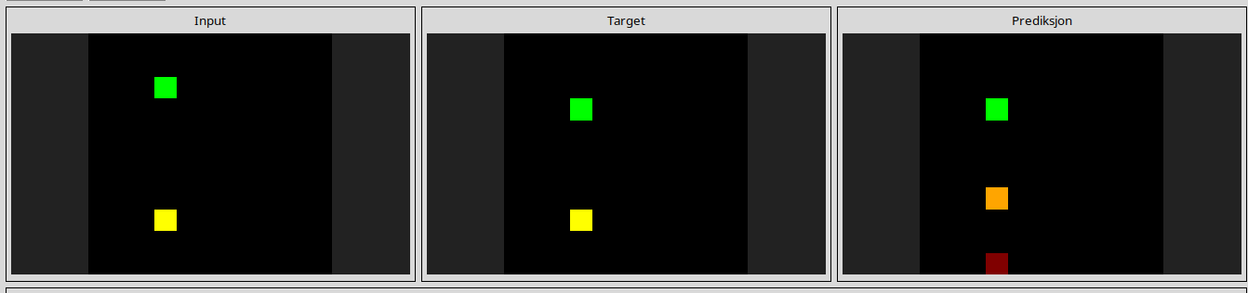
l
de1cd16c
